# *Opinion / Editorial Piece*

**Jonas (Yunzhe) Li**

|  |  |
| --- | --- |
| **Desired Audience:** | Medical and healthcare professionals, students in fields related to surgery |
| **Communitive Goals**: | To inform the audience about the current capabilities and limitations of surgical robots, highlighting their role in modern surgery and the potential for increased autonomy in the next dec |
| **Constraints:** | Lack of technical information explanation in an accessible way for a diverse audience |

**SID: 3040802664**

**Surgical Robots: With full autonomy in the next decade**

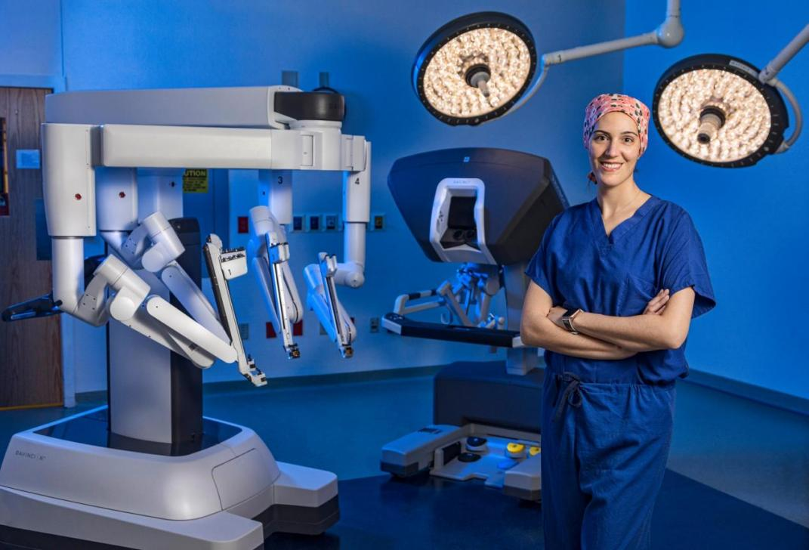

**Figure 1.** The Future Operating Room

As you lie on the operating table, the anesthesiologist counts down from 10. By the time they reach 7, you see two figures moving above you—a robot and the operating surgeon, as shown in Fig. 1. Today, surgical robots are primarily used to assist surgeons in minimally invasive procedures, providing increased precision, dexterity, and control. With rapid advancements in artificial intelligence and robotics, fully autonomous surgical robots are likely to replace human surgeons in specific procedures within the next decade, offering greater precision, consistency, and efficiency in routine surgeries. You’ll have a robot surgeon, and you should feel safer as a result.

**Table 1.** Comparison between human surgeons and robot surgeons

|  |  |  |
| --- | --- | --- |
| **Aspect** | **Human surgeons** | **Robot surgeons** |
| Consistency | Varies with fatigue and stress | High, unaffected by external factors |
| Precision | Limited by hand stability | Superior micromovements |
| Invasiveness | Often larger incisions | Minimally invasive, less trauma |
| Complications | Higher risk of blood loss, infections | Lower risk, smaller incisions |
| Efficiency | Dependent on individual capacity | Scalable, reduces hospital burden |

Why do we need highly autonomous robot surgeons? The benefits are summarized in Table 1. Even the most skilled surgeons can experience fatigue, stress, or hand tremors, which may lead to errors during delicate operations. Autonomous systems, however, can operate with consistent precision for extended periods, unaffected by such external factors. These robots can be programmed to make micromovements beyond the capabilities of the human hand, achieving higher accuracy in procedures that demand meticulous detail. This is particularly beneficial in microsurgeries or procedures that require navigating narrow spaces, reducing complications and improving patient outcomes. Additionally, autonomous robots are more likely to perform surgeries with minimally invasive techniques, which reduce trauma to the body. These procedures result in smaller incisions, less blood loss, and fewer postoperative complications such as infections.

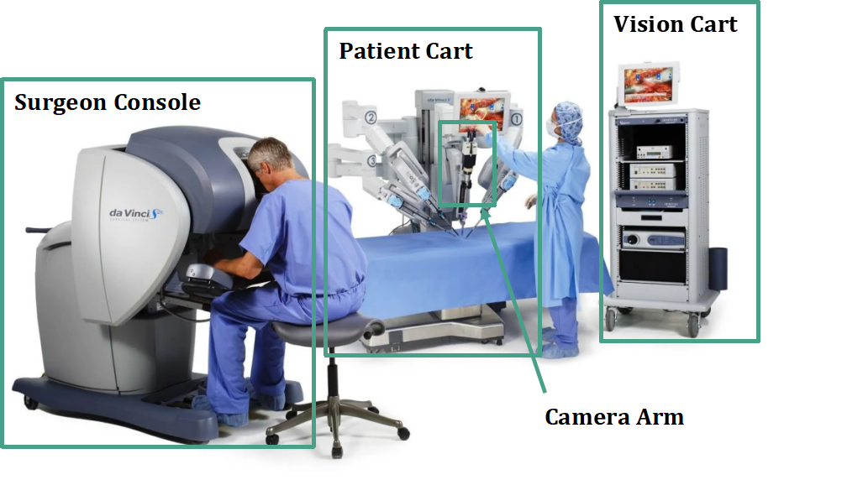

**Figure 2.** Da Vinci robotic surgical system

Current surgical robots, such as the da Vinci Surgical System shown in the Fig. 2, have achieved a degree of autonomy in assisting human surgeons. These systems have demonstrated high success rates in various types of surgery, as shown in Table 2, and excel in tasks that require precision, such as stabilizing instruments and minimizing hand tremors, thereby enhancing the accuracy of minimally invasive procedures. Equipped with multi-arm configurations and intuitive controls, they have become indispensable tools in modern surgery. However, despite their advanced capabilities, these robots still rely on human surgeons for guidance and control, as they are not yet fully autonomous.

**Table 2.** Different types of surgical robots

|  |  |  |  |
| --- | --- | --- | --- |
| **Surgical Robot Systems** | **Type of Surgery** | **Success Rate (%)** | **Task It Excels At** |
| Da Vinci Surgical System | Prostatectomy | 90-98% | minimally invasive prostate surgeries;  lower rates of complications;  faster recovery times |
| Mako Robotic-Arm Assisted | Knee and Hip Replacement | 97-99% | orthopedic surgeries;  better outcomes in joint replacement |
| CorPath GRX | Percutaneous Coronary Angioplasty | 96-98% | clear blocked arteries in heart surgeries;  precise catheter placement;  improved procedure outcomes |
| ROSA Robotic System | Neurological Surgery | 93-95% | brain and spinal surgeries;  highly accurate targeting in complex neurological procedures |

Previously, the progression toward fully autonomous surgical robots has been hindered by several significant challenges. One major bottleneck is the complexity of real-time image processing; surgical environments are dynamic, and accurately interpreting visual data in real-time is crucial for effective operation. Another challenge lies in decision-making; surgeons must make immediate judgments and adapt to unexpected complications or anatomical variations during procedures. Additionally, the lack of force feedback—also known as haptic feedback—limits a robot's ability to replicate the tactile sensations that surgeons rely on to assess tissue characteristics and apply appropriate force, which is essential for delicate manipulations.

Recent advancements have begun to address these challenges. In real-time image processing, the integration of artificial intelligence has significantly improved the ability of surgical robots to interpret complex visual data swiftly and accurately, enhancing their adaptability during operations[1]. For decision-making, AI-driven systems are being developed to assist in surgical planning and intraoperative guidance, enabling robots to make informed decisions and adapt to unforeseen situations[2]. Regarding force feedback, new technologies are being incorporated to provide surgeons with tactile sensations through robotic instruments, improving their ability to perform delicate tasks with greater precision. These developments collectively contribute to the gradual evolution of surgical robots toward greater autonomy and effectiveness in the operating room.

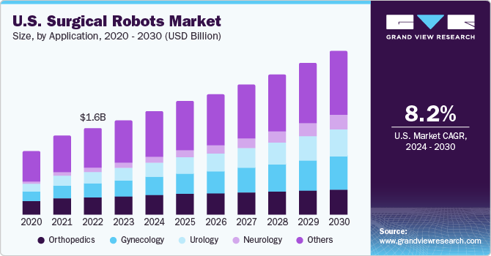

**Figure 3.** U.S. Surgical Robots Market

With the growing surgical robot market as shown in Fig. 3, leading companies like Intuitive Surgical, Stryker, and Zimmer Biomet, alongside major research universities, are at the forefront of this innovation, working to overcome these challenges. These companies specialize robots that replicate, and in some cases, even surpass human abilities. Researchers at Johns Hopkins University have demonstrated the Smart Tissue Autonomous Robot (STAR)[3], a system capable of performing soft tissue surgeries with remarkable precision, such as suturing, often outperforming human surgeons in consistency and accuracy. Meanwhile, at MIT, researchers are developing robotic systems that can use real-time data from imaging technologies like MRI and CT scans to adjust surgical approaches dynamically, enabling more personalized and adaptive surgeries.

As fully autonomous surgical robots become more capable, questions of liability and ethical responsibility are gaining prominence. Who would be accountable in the event of a malfunction— the hospital, the manufacturer, or the developers of the AI algorithms? Addressing these concerns will require collaboration among regulatory bodies, healthcare providers, and technology developers to establish clear frameworks that protect both patients and innovators. However, the promise these systems hold for the next decade is undeniable. As advancements in artificial intelligence, haptic feedback, and real-time decision-making continue, fully autonomous surgical robots are poised to transform healthcare. With proper oversight and continued technological refinement, we can anticipate a future where autonomous systems enhance surgical precision, reduce human error, and expand access to high-quality care across the globe. The next decade may very well see these robots not only supporting but redefining the role of surgery in medicine.

[967 words]

1. Morris, Miranda X., et al. "Current and future applications of artificial intelligence in surgery: implications for clinical practice and research." Frontiers in Surgery 11 (2024): 1393898.
2. Knudsen, J. Everett, et al. "Clinical applications of artificial intelligence in robotic surgery." Journal of Robotic Surgery 18.1 (2024): 102.
3. Johns Hopkins University. (2022, January 26). Robot performs keyhole surgery on pig’s soft tissue. The Hub. <https://hub.jhu.edu/2022/01/26/star-robot-performs-intestinal-surgery/>
4. Barnoy, Y., O'Brien, M., Wang, W., & Hager, G. (2021). Robotic surgery with lean reinforcement learning. arXiv preprint arXiv:2105.01006.
5. Ma, R., Vanstrum, E. B., Lee, R., Chen, J., & Hung, A. J. (2020). Machine learning in the optimization of robotics in the operative field. Current opinion in urology, 30(6), 808-816.
6. Lee, A., Baker, T. S., Bederson, J. B., & Rapoport, B. I. (2024). Levels of autonomy in FDA-cleared surgical robots: a systematic review. NPJ Digital Medicine, 7(1), 103.
7. Schmidgall, S., Krieger, A., & Eshraghian, J. (2024, May). Surgical Gym: A high-performance GPU-based platform for reinforcement learning with surgical robots. In 2024 IEEE International Conference on Robotics and Automation (ICRA) (pp. 13354-13361). IEEE.